Delhi Public Academy

Class--1st

Subject– Maths

Q.1 Write 1 to 10 Roman numbers with help

Matchsticks in A4 size sheet.

Q.2 Draw different types of shape with

Colour paper and write there name.

Q.3 Help butterfly to find her way.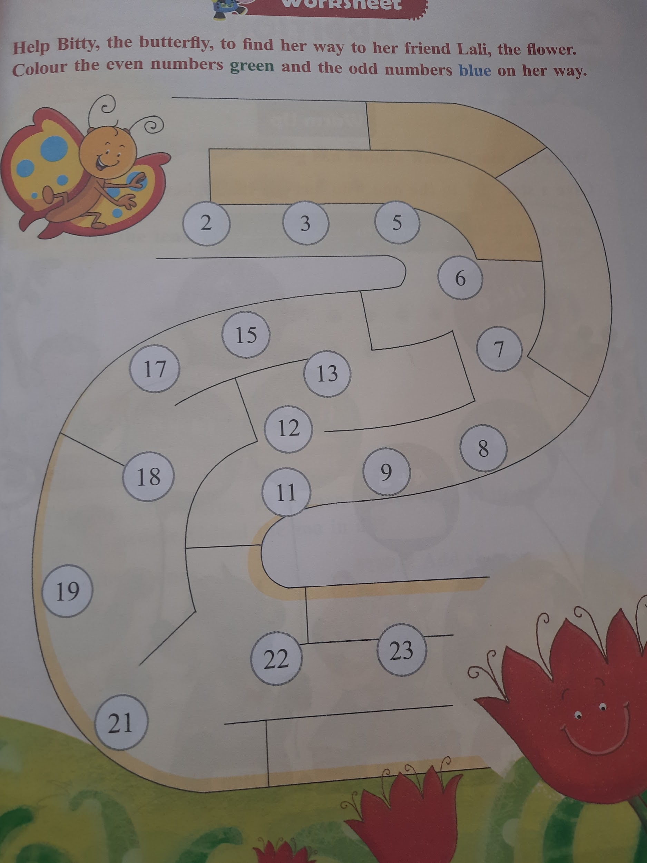

Q.4 Write 1 to 30 numbers name.

Q.5 How many different ways numbers

add to make 10.